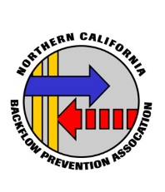
NCBPA will be holding it’s Annual Product Show
Thursday August 12, 2021

Veterans Park
3841 Balfour Road, Brentwood, CA 94513

Check in Time: 8:30 Product Show/ Workshop:
9:00 a.m.—2:00 p.m.
Earn 4 contact hours

NO MOTORCYCLES, NO DOGS AND NO REFUNDS

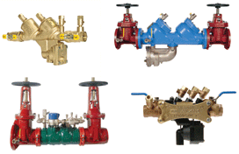
A Steak Lunch will be provided for those who have pre-registered

Cost: Members: $40.00 Non-Members: $60.00
(Does not include membership)

RESERVATIONS MUST BE IN BY AUGUST 10, 2021

Please Mail Registration form to: NCBPA P.O. Box 6177, Vallejo, CA 94591
Lacy Castro (707) 731-4239 or Fax: (707) 649-0429 or

e-mail ncbpacustserv@yahoo.com

——————————————————————————————————————————————————————————

NCBPA Annual Product Show / August 12, 2021
Name(s): Company:

Phone:

Fax:

Email:

Payment method (Circle One) Check Mastercard Visa Discover Exp Date: Credit Card # Name as it Appears on Card Billing address of Credit Card:
Number of attendees @ $40 members _@ $60 non-members Total Enclosed $_ Make checks payable to: NCBPA P.O. Box 6177, Vallejo, CA 94591 (No Refunds)

